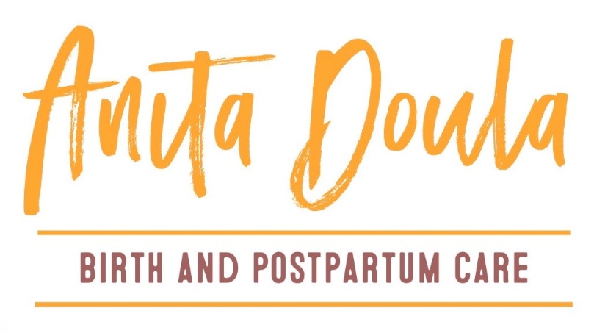
Labor Support and TENS UNIT RENTAL AGREEMENT
I release Anita Ortega of Anita Doula from any liability, injury, or property damage that may result from the use of the TENS unit. I agree to use the TENS unit only as instructed as per the manual.
I am renting the TENS until for my own personal use. Anita Ortega is not liable for injury or damage to a third party.
I agree to return the TENS unit equipment on 4 weeks from the date of rental. I am responsible for setting up, packing and returning the TENS unit and equipment in clean and good working order. Electrodes are not returned as they are designed for a single user.
Terms:
If the TENS unit or equipment is returned damaged or not returned at all, I will pay Anita Ortega the reasonable cost of full replacement value as decided by Anita Ortega up to $200. I understand there will be no refund or reduction of fees for borrowing a TENS unit and choosing to not use the unit during the rental period. All fees are non-refundable.
I may extend my borrowing period upon notice to Anita Ortega before the due date if it is not already on reservation. The Fee is based on a two week period and costs $25. A late fee of $10 will be charged for each additional day that the TENS unit and accessories are late.
What is a TENS unit:
TENS stands for Transcutaneous Electrical Nerve Stimulator. The TENS unit releases a low frequency electric current through the skin which stimulates your body’s endorphins. When these sensory nerves are stimulated they naturally slow down the body’s ability to perceive pain and help release your own natural painkiller. This technique is called “pain gateway theory”. The TENS can be used during labor, with or without an epidural, and with or without wireless monitoring. Not to be used in the bath, shower or in any water.

The TENS Unit:
- The TENS unit
- 1 Lanyard
- 1 set of leads
- 2 sets of batteries
- Instruction manual
- Carrying case
- Pack of electrodes (good for up to 30 applications)
Labor Support:
- Hot packs (4)*must be returned
- Quick Energy Support
- Position cards
- Birth Affirmations
- Text, Email and Phone Support *through pregnancy and postpartum/excludes L&D*
Payment Plan
The full amount of $150 is due upon signing of the contract.
I have read and understood the information listed above. By signing this agreement, I consent to receive a TENS UNIT RENTAL from ANITA ORTEGA of Anita Doula.
Print Name: ___________________________________________________________________
Signature: __________________________________ Date: _____________________________
Address: ______________________________________________________________________
Phone: _______________________________ Email: ___________________________________
Due Date: _______________________ Birthing Facility/Provider:_________________________
Rental Date:____________________ Due Date (4 week after rental date):__________________
Anita Ortega Signature: __________________________________________________________
Return the TENS unit in a padded packing envelope to:
16221 Dogwood Ln
Arlington, WA 98223
Phone: (360)322-2975/Email: anita@anitadoula.com

